Bangladesh Army International University of Science and Technology
Department of Computer Science and Engineering
Lab Report
Lab Report No | : | 02
Lab Report Name | : | Design and Implementation of Basic Web Components Using HTML
Course Title | : | Web Technology Sessional
Course Code | : | CSE 324
Name | : | Jannatul Ferdous
ID | : | 1119018
Level | : | 3 | Term | : 2 | Section | : A | Group | : 1
Date of Submission | : | 19.10.2026 | Semester | : Fall | Year | : 2026

Marking Rubric
Problem Understanding & Report Clarity (3) | Implementation (4) | Results, Analysis & Presentation (3) | Total

Key Learnings:
- Understand the structure of an HTML document and use essential tags and attributes effectively.
- Apply semantic elements to organize content and improve accessibility.
- Design basic web layouts and components such as forms, tables, and navigation menus.
- Follow best practices to write clean, readable HTML and understand its role as the foundation of web development.

Task 1: Design a Product Card
Code :
<!DOCTYPE html>
<html lang="en">
<head>
<meta charset="UTF-8">
<meta name="viewport" content="width=device-width, initial-scale=1.0">
<title>Product Card</title>
<style>
body {
background-color: lightgray;
font-family: Arial, sans-serif;
margin: 0;
padding: 20px;
}
.container {
display: flex;
justify-content: center;
align-items: stretch;
gap: 20px;
flex-wrap: wrap;
}
.card {
background-color: white;
width: 250px;
padding: 15px;
border: 1px solid gray;
display: flex;
flex-direction: column;
}

.card img {
width: 100%;
height: 220px;
object-fit: cover;
}
.card h2 {
color: brown;
font-size: 24px;
margin: 20px 0 10px;
}
.card p {
color: gray;
font-size: 16px;
margin: 8px 0;
line-height: 1.5;
}
button {
background-color: brown;
color: white;
padding: 10px;
border: none;
cursor: pointer;
align-self: flex-start;
margin-top: 8px;
}
</style>
</head>
<body>
<div class="container">
<div class="card">
<img src="bread.jpg" alt="Baked Bread">
<h2>Baked Bread</h2>
<p>Fresh and tasty baked bread.</p>
<p>Price: $20.99</p>
<button>Buy now</button>
</div>
<div class="card">
<img src="soup.jpg" alt="Fresh Soup">
<h2>Fresh Soup</h2>
<p>Healthy and delicious fresh soup.</p>
<p>Price: $15.99</p>
<button>Buy Now</button>
</div>
</div>
</body>
</html>

Output :
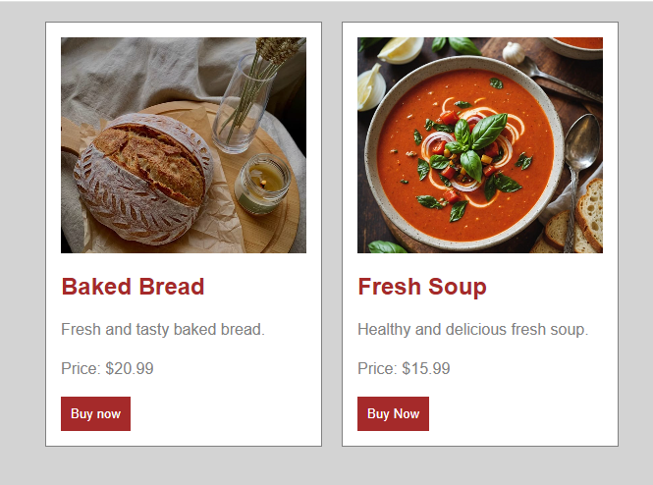

Task 2: Student Result Table
Code :
<!DOCTYPE html>
<html lang="en">
<head>
<meta charset="UTF-8">
<meta name="viewport" content="width=device-width, initial-scale=1.0">
<title>Student Result Table</title>
<style>
body {
font-family: Arial, sans-serif;
margin: 30px;
}
h2 {
text-align: center;
color: darkblue;
}
table {
width: 100%;
border-collapse: collapse;
margin-top: 20px;
}
th, td {
border: 1px solid black;
padding: 10px;
text-align: center;
}
thead {
background-color: #d9eaf7;
}
.department {
background-color: #e8f5e9;
font-weight: bold;
}
tfoot {
background-color: #fff0cc;
font-weight: bold;
}
</style>
</head>
<body>
<h2>Student Result Table</h2>
<table>
<thead>
<tr>
<th>Department</th>
<th>Student ID</th>
<th>Name</th>
<th>English</th>
<th>Mathematics</th>
<th>Total Marks</th>
<th>Grade</th>
</tr>
</thead>
<tbody>
<tr>
<td class="department" rowspan="3">CSE</td>
<td>1119001</td>
<td>Jannatul Ferdous</td>
<td>85</td>
<td>90</td>
<td>175</td>
<td>A+</td>
</tr>
<tr>
<td>1119002</td>
<td>Khandakar Naba</td>
<td>78</td>
<td>82</td>
<td>160</td>
<td>A</td>
</tr>
<tr>
<td>1119003</td>
<td>Sakib Ahmed</td>
<td>92</td>
<td>95</td>
<td>187</td>
<td>A+</td>
</tr>
<tr>
<td class="department" rowspan="2">EEE</td>
<td>229001</td>
<td>Rezowan Ahmed</td>
<td>75</td>
<td>80</td>
<td>155</td>
<td>A</td>
</tr>
<tr>
<td>229005</td>
<td>Tanvir Hasan</td>
<td>68</td>
<td>72</td>
<td>140</td>
<td>B</td>
</tr>
</tbody>

<tfoot>
<tr>
<td colspan="5">Class Average (Total Marks)</td>
<td>163.4</td>
<td>A-</td>
</tr>
</tfoot>
</table>
</body>
</html>

Output :
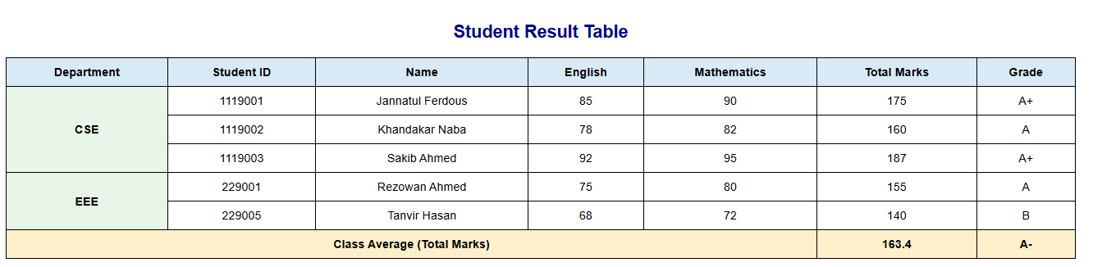

Task 3: Personal CV
HTML Code :
<!DOCTYPE html>
<html lang="en">
<head>
<meta charset="UTF-8">
<meta name="viewport" content="width=device-width, initial-scale=1.0">
<title>My Resume</title>
<link rel="stylesheet" href="style.css">
</head>
<body>
<div class="resume">
<div class="left-side">
<div class="profile">
<div class="photo">
<img src="pic.jpg" alt="My Photo"></div>
<h2>Jannatul Ferdous</h2>
<p>Web Developer</p>
</div>
<div class="section">
<h3>Contact</h3>
<p>☎ +880 1882 709675</p>
<p>✉ jan.nat1119018@gmail.com</p>
<p>⌂ Cumilla Cantonment , Cumilla , Bangladesh</p>
</div>
<div class="section">
<h3>Education</h3>
<h4>BSc in Computer Science</h4>
<p>Bangladesh Army Internation University of Science & Technology</p>
<p>2024 - 2028</p>
</div>
<div class="section">
<h3>Skills</h3>
<p>HTML & CSS</p>
<p>JavaScript</p>
<p>Communication</p>
</div>

</div>
<div class="right-side">
<h1>Jannatul Ferdous</h1>
<p class="job-title">WEB DEVELOPER</p>
<div class="section">
<h3>Profile</h3>
<p>
I am a motivated web developer who enjoys
creating simple and attractive websites.
I am eager to learn new technologies and
improve my programming skills.
</p>
</div>
<div class="section">
<h3>Experience</h3>
<h4>Junior Web Developer</h4>
<p class="date">2025 - Present</p>
<p>
Created simple web pages using HTML and CSS.
Worked on page layouts, colors and responsive
designs.
</p>
<h4>Web Design Intern</h4>
<p class="date">2025 - Present</p>
<p>
Practiced website design and learned how
to organize content using HTML and CSS.
</p>
</div>
<div class="section">
<h3>Projects</h3>
<h4>Personal Portfolio Website</h4>
<p>
Designed a personal website to display
projects, skills and contact information.
</p>
</div>
</div>
</div>
</body>
</html>

CSS Code :
body {
margin: 0;
padding: 40px 15px;
background-color: #333333;
font-family: Arial, sans-serif;
}
.resume {
width: 700px;
margin: auto;
background-color: white;
display: flex;
border-top: 6px solid #d8b49b;
box-shadow: 0 3px 15px rgba(0, 0, 0, 0.3);
}
.left-side {
width: 32%;
background-color: #ead0bd;
padding: 20px 15px;
box-sizing: border-box;
}
.profile {
text-align: center;
border-bottom: 1px solid #bda18e;
padding-bottom: 15px;
}
.photo {
width: 100px;
height: 100px;
border-radius: 50%;
overflow: hidden;
margin: 0 auto;
background-color: #555;
}
.photo img {
width: 100%;
height: 100%;
object-fit: cover;
display: block;
}
.profile h2 {
font-size: 17px;
margin: 8px 0;
text-transform: uppercase;
}
.profile p {
font-size: 11px;
margin: 5px 0;
}
.section {
margin-top: 25px;
}
.section h3 {
font-size: 13px;
text-transform: uppercase;
letter-spacing: 2px;
border-bottom: 1px solid #888888;
padding-bottom: 5px;
margin-bottom: 12px;
}
.section h4 {
font-size: 12px;
margin: 12px 0 5px;
}
.section p {
font-size: 11px;
line-height: 1.7;
color: #444444;
margin: 5px 0;
}
.right-side {
width: 68%;
padding: 30px 25px;
box-sizing: border-box;
}
.right-side h1 {
font-size: 27px;
letter-spacing: 2px;
margin: 0;
text-transform: uppercase;
}
.job-title {
font-size: 11px;
letter-spacing: 2px;
margin-top: 8px;
color: #555555;
}
.date {
color: #a16d4d !important;
font-weight: bold;
}
@media (max-width: 600px) {
.resume {
width: 100%;
}
.left-side {
width: 38%;
padding: 15px 10px;
}
.right-side {
width: 62%;
padding: 20px 12px;
}
.right-side h1 {
font-size: 20px;
}
.section h3 {
font-size: 11px;
}
}
Output :
